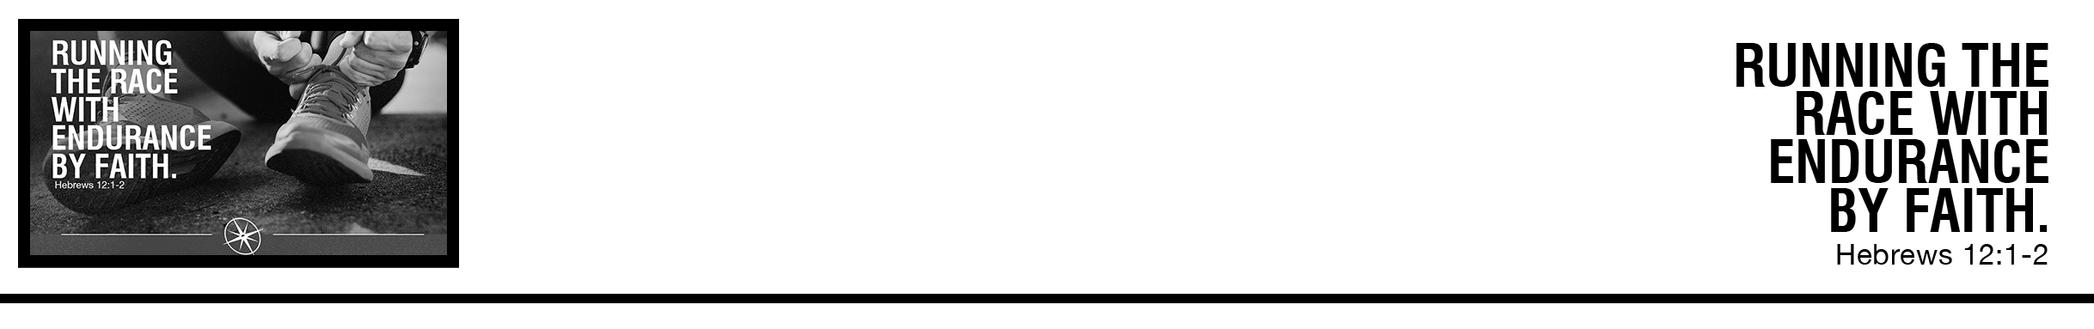Description: confused 02

Dr. Thomas White • Compass Bible Church • July 29 & 30, 2017 • Msg. # G17-07

***1****Therefore, since we are surrounded by so great a cloud of witnesses, let us also lay aside every weight, and sin which clings so closely, and let us run with endurance the race that is set before us,****2*** *looking to Jesus, the founder and perfecter of our faith, who for the joy that was set before him endured the cross, despising the shame, and is seated at the right hand of the throne of God.* (ESV)

***Notes:***

**Application Questions**

*These questions are provided for your further study and application of today’s sermon. Thoughtfully writing out the answers to these questions will help to drive home the point of today’s study. It is also helpful when you are able to discuss your answers with others. For more information about small groups at Compass Bible Church that utilize these questions as the basis for their weekly discussion, please call the church office at (949) 540-0699 or email us at SmallGroups@CompassChurch.org.*

1. Read **Hebrews 11.** What do the many failures of the people listed in Hebrews 11 teach us about who God uses, God’s grace, and whether God could use us?

2. What “weights” are holding you back from running full speed toward Jesus? What sins temp you the most or cling most closely to you?

3. Are you running your race well, or have you given up? Do you lack endurance during the trials of life?

4. Read **John 21:20-22**. Do you focus on running the race set before *you*, or do you wish you were running someone else’s race?

*This Week’s  
Bible Reading Schedule*

**July 30th**

*Ps.59-61 & Ac.28:16-31*

**July 31st**

*Ps.62-64 & Ro.1*

**August 1st**

*Ps.65-67 & Ro.2*

**August 2nd**

*Ps.68-69 & Ro.3*

**August 3rd**

*Ps.70-72 & Ro.4*

**August 4th**

*Ps.73-74 & Ro.5*

**August 5th**

*Ps.75-77 & Ro.6*

**August 6th**

*Ps.78 & Ro.7*

5. Read **Hebrews 12:1-2**. What things of this world tend to distract you from looking to Jesus?

6. Make a list of some of the ways God has shown himself faithful in your life. Right now, are you living in a way that shows you trust him?

cleardot